**Coursework Documentation-Tenusha Amaradiwakara**

The code can be run by opening the “cardealer.jar” file and the program loads into the login page. The file called “txtfiles” should be in the same directory as “cardealer.jar” file as it contains all the necessary data files needed to run the program and “txtfiles” contains all the text files. when the program is started for the first time there will be data in car-users.txt which will contain all user details for login and cars-import will contain a list of cars that the user can import into cars-database which is initially empty unless users adds cars to it. Cars-output file will also be empty unless user selects print cars button. Find below what the txtfiles contain originally. Please note The GUI was designed in macOS and when run on windows will have design inconsistencies. All the testing of the program was carried out in macOS as evident on screenshots.

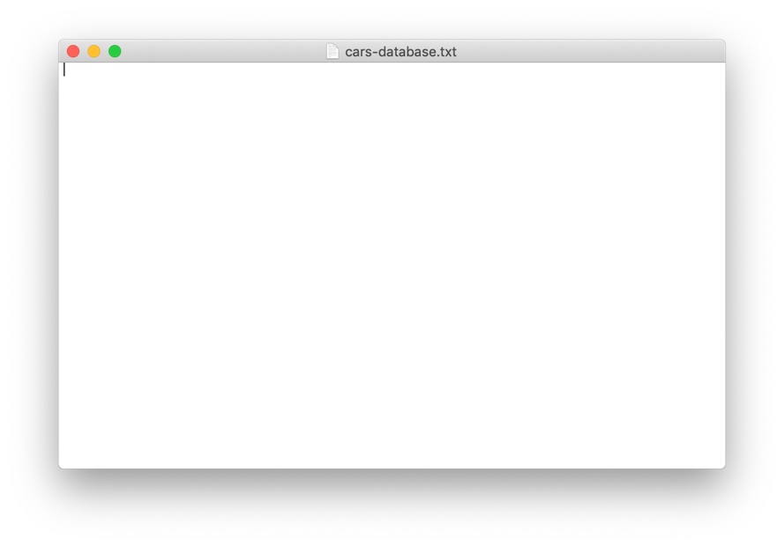

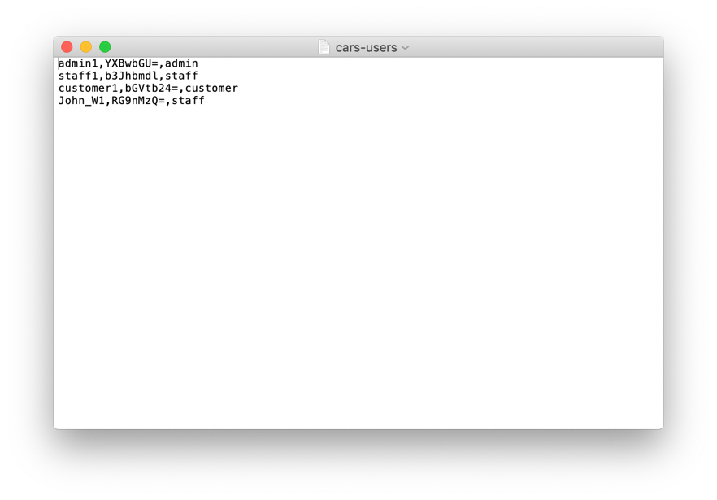

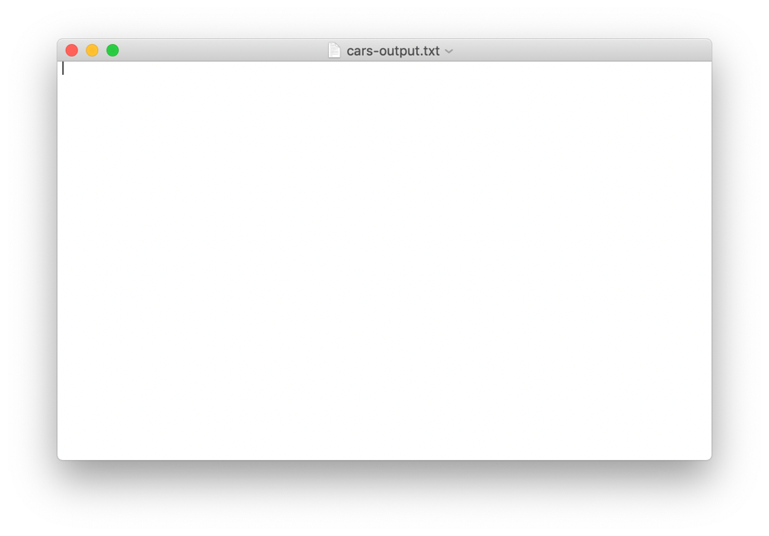

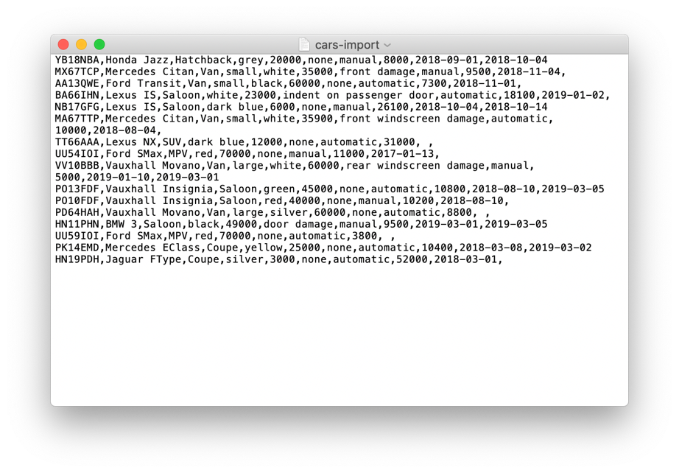

***User Instructions***

When program is run user is entered into the login page, where the appropriate user can put their login credentials to login. The user can also reset all text fields if the reset button is clicked. And can exit the program by pressing the exit button. Default login details admin1-apple, customer1-lemon, staff1-orange.Deatils are contained in car-users.txt file



When user type admin is signed in the program loads into the admin area. From This menu the user can navigate the user interface using the menu bar at the top into different functionality of the program the user can click on the name of the functionality on top to navigate.



Admin Main menu contains the create login details function and the user can enter the type of user and set a username and password for the user and add the user into the program. The user has to be unique and the program checks for duplicate users



Staff main menu

Customer page is not navigable as the customer can only search for cars without the accident history



Customer main menu

***The search*** accessible by all user types but customer without accident history, is split into different criterial the user can enter data into any of the criteria they wish and click the appropriate button to execute a search for cars. All data is read from cars-databse.txt file.

* For criteria 1 user needs to enter a matching car model and its transmission and if the car is found in databse.txt and is unsold and available the information about car is outputted into the text area to the right if not user prompted with error message.

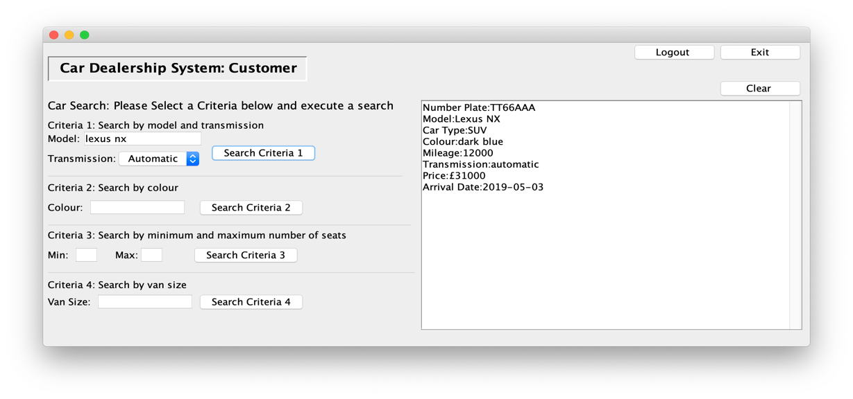

* For criteria 2 user needs to enter an appropriate colour and all available cars with matching colour is outputted into text area.



* For criteria 3 user can enter a minimum and maximum number of seats and search outputs the available cars that has the number of seats between the given criteria.



* For criteria 4 user enter a van size small or large and all available vans that match the size is outputted.



***Add cars function***  is accessible by both admin and staff. The user can add cars into the database by filling in the form of all the required details and clicking add car button the data is added to databse.txt file. All fields are required except size (only if van) and arrival date is set to current date if empty and sell date can be left blank. Data is added to cars-databse.txt





***Calculate revenue*** accessible by both admin and staff user can enter a month and year to calculate the total money earned by sold cars or the user can enter a specific date and click button and method returns the total money earned for that specific date. Data is read from cars-databse.txt file





***Sell cars*** accessible by both admin and staff. User needs to enter a valid number plate stored in the database.txt and sell date is not before the date of arrival and not yet sold, if the inputs pass all these checks the cars sell date is set as the given date and marked as sold

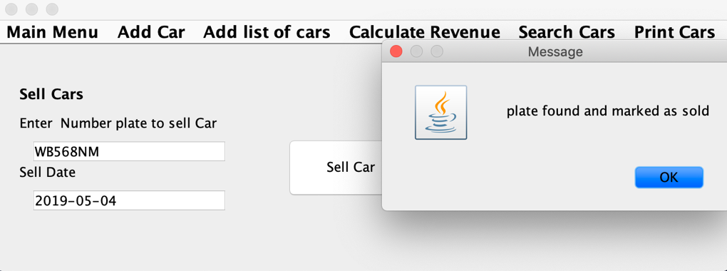

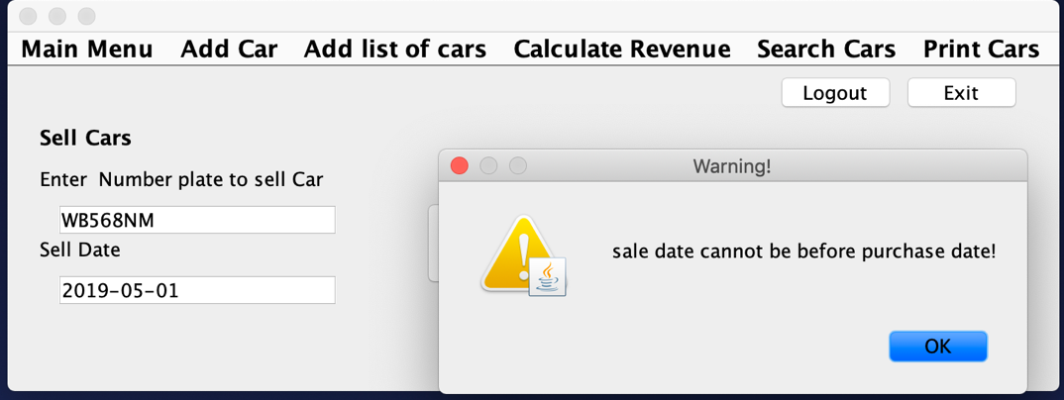

When sell date is before arrival date

 When user tries to sell a car that’s already sold



When user enters an incorrect number plate

***Print cars*** accessible by admin and staff. User clicks the button to print cars and program outputs a print-cars.txt file in the “txtfile” directory, cars sorted into sold and unsold and sorts the sold car list by sell date in ascending order and unsold car list by arrival date in ascending order.



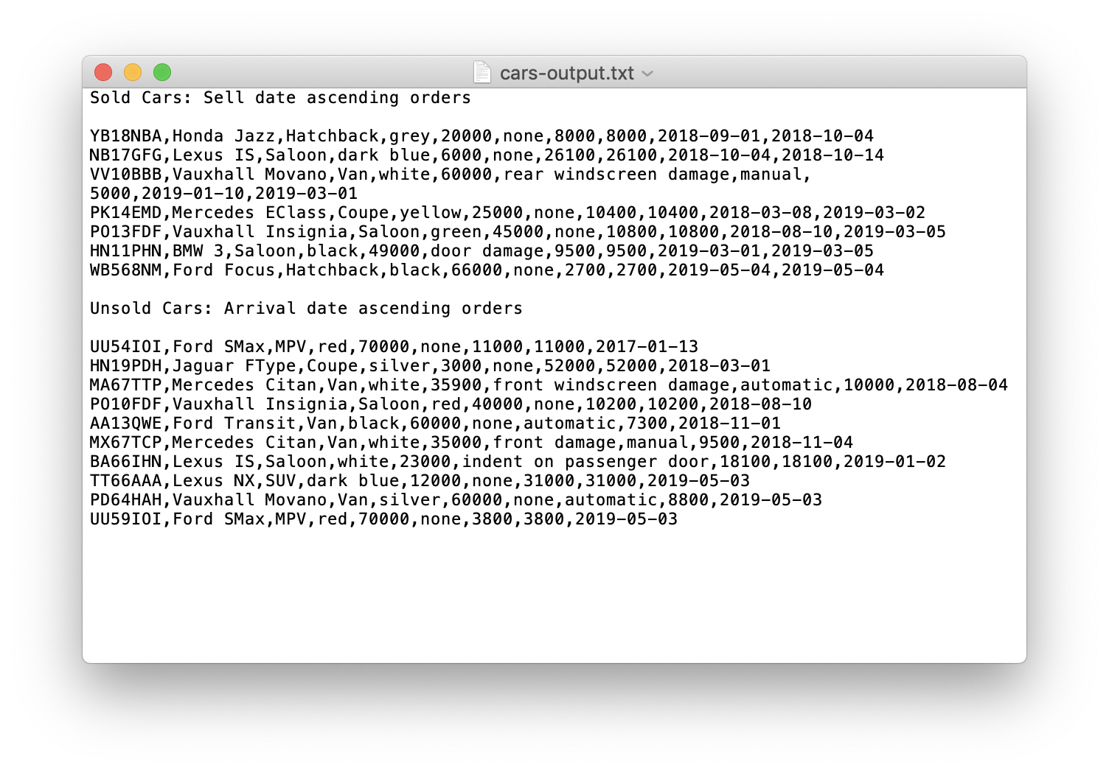

***Add list of cars from file*** accessible by both admin and staff. When user has clicked the “import cars file” button a window will open(file chooser) for the user to navigate to the directory txtfiles and to open cars-import.txt file then the data in cars-import.txt file in txtfiles directory will be added to the database if and only if there are no cars already exists in database with the same number plate if it does user is asked to edit the file and try again.

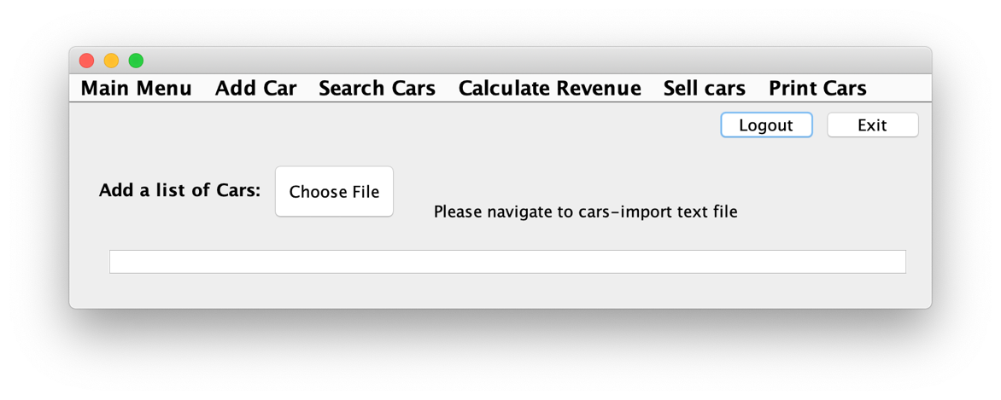

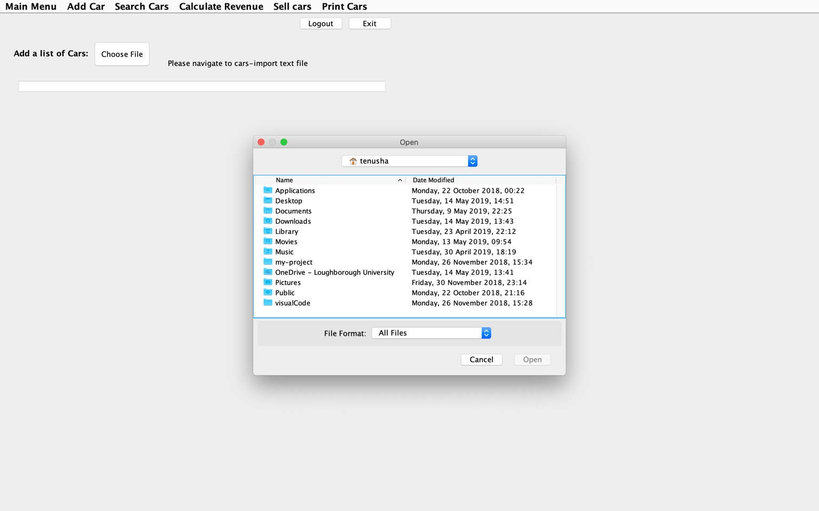

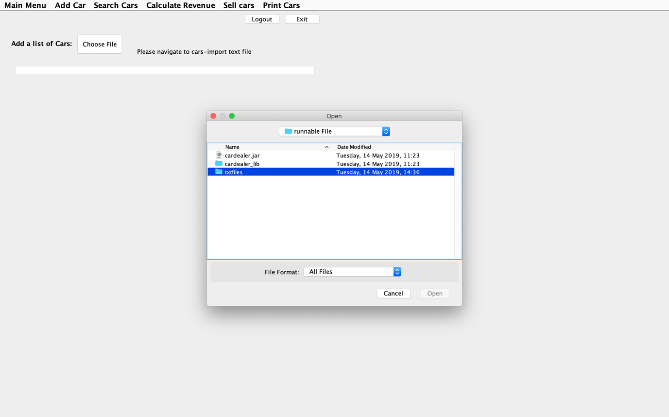

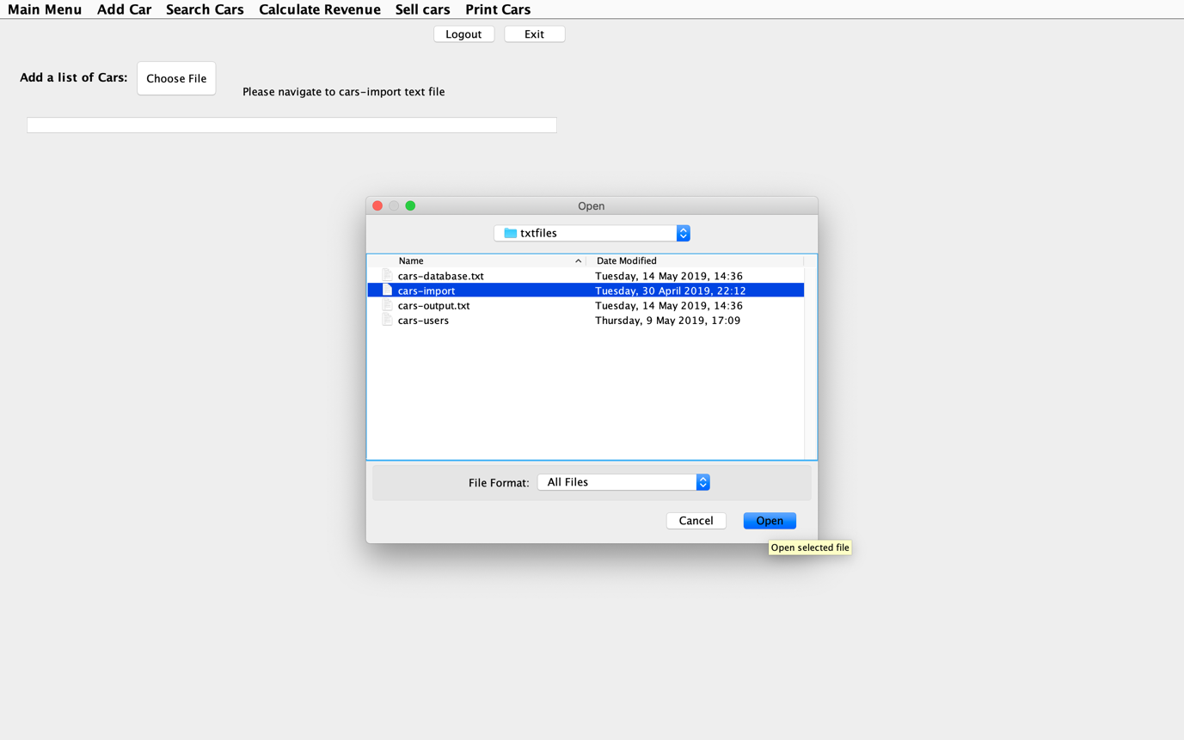

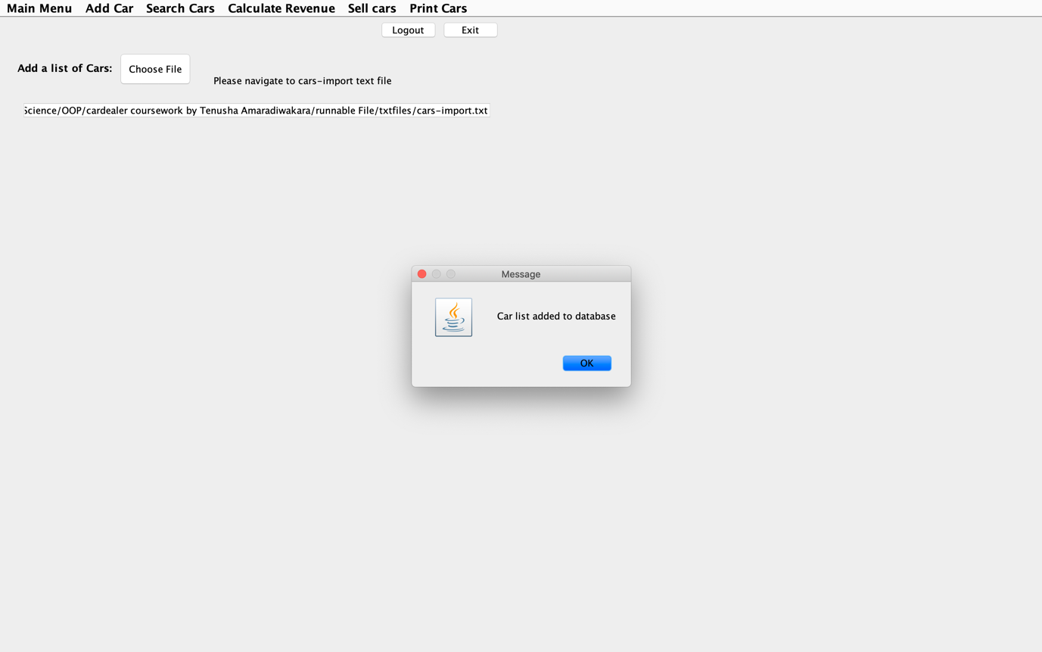



When user tries to add a car that already exists



**Packages used to develop program**

* Java.io
* Java.swing
* Java.util
* Javax.swing
* Java.awt
* *Created packages- Main, main.LoginSys, main.Staff, main.Customer, main.Admin*

**Class Diagram**

The program was split into different sections, Firstly, an abstract class called vehicle was created and a class called Car was created as each Car is type of vehicle. In the car class all the attributes of a Car are added such as registration number, mileage … etc. As there are different types of cars subclasses that inherit the super class Car was created such as MPV, SUV, coupe, Saloon, hatchback and van. These classes also have their attributes as well as attributes inherited from Car class as each type has the attributes number of seats and number of doors pre-set and class van has an extra attribute size. And all class contain their constructors. The class User is another main class has the attributes username, password and role this class is used to create objects of different types of users for the system. An abstract inherited class called staff Is created which implements all the methods(static) used by both admin and staff as admin has access to all the functionality as Staff and able to create login details. Therefore, the class admin inherits the staff class. The customer class also inherits the class staff as it uses the read files method and has its own methods as it has a similar search to admin and staff but without accident history therefore it is implemented separately in customer class. The login system is a class that is composed within the staff class and it implements the level of access to the system and check usernames and passwords and grants access.

**Testing plans**

|  |  |  |  |  |
| --- | --- | --- | --- | --- |
| ***Functionality Name*** | ***Test Data*** | ***Outcome*** | ***Was the outcome as expected?*** | ***Image ref. (link to image if the test involves screenshot)*** |
| Login system | Username=admin1  Password=apple | Login to admin GUI | Yes, outcome as expected | [Result](https://photos.app.goo.gl/nLDGNrQf1gQzZSEB8) |
| Login system | Username=staff1  Password=orange | Login to staff GUI | Yes, outcome as expected | [Result](https://photos.app.goo.gl/PW4ZbTAQibmpsG9e9) |
| Login system | Username=customer1  Password=lemon | Login to customer GUI | Yes, outcome as expected | [Result](https://photos.app.goo.gl/22oMXBATkwBAvt2GA) |
| Login System | Incorrect login details | Error message | Yes, outcome as expected | [Result](https://photos.app.goo.gl/GsNpZKC3PeomB42x5) |
| Add Car | Adding new car | New Car added to car-databse.txt | Yes, outcome as expected | [Result](https://photos.app.goo.gl/45RrJDcVi41MqFhE8) |
| Add Car | Adding a car that already exists | Error message | Yes, outcome as expected | [Result](https://photos.app.goo.gl/1LfGgBgeqUFLQHAJ8) |
| Add list of cars | Adding a list of cars from cars-import.txt file | Cars added to database if and only if there are no cars that already contain same number plates in databse.txt | Yes, outcome as expected | [Result](https://photos.app.goo.gl/aHDcepf2JQ25ntkq8) |
| Add list of cars | Tring to add a list of cars that have already been imported | Cars not added to database user asked to edit file | Yes, outcome as expected | [Result](https://photos.app.goo.gl/3iguZ6EztfMsVLTJ6) |
| Search cars Criteria 1 | “Ford Focus” car searched by giving model and correct transmission | Details about car outputted to text area | Yes, outcome as expected | [Result](https://photos.app.goo.gl/zHC6YT3Emn4WJseF7) |
| Search cars Criteria 1 | Incorrect data searched | Error message | Yes, outcome as expected | [Result](https://photos.app.goo.gl/ksqNEED5wBZdkcsUA) |
| Search cars Criteria 2 | Searched for cars with colour “white” | Details of all cars that matches colour white and are unsold outputted | Yes, outcome as expected | [Result](https://photos.app.goo.gl/qeJhyk9DTKWCYphX6) |
| Search cars Criteria 2 | Search for a colour that’s not available or found | Error message | Yes, outcome as expected | [Result](https://photos.app.goo.gl/j21Q6R486WBY16F67) |
| Search cars Criteria 3 | Search cars between 1-2 number of seats | Car/cars that are available and contains that number of seats | Yes, outcome as expected | [Result](https://photos.app.goo.gl/yCNk32yT5Da2sn5a6) |
| Search cars Criteria 3 | Searches cars with extreme data 20-30 seats | Error message | Yes, outcome as expected | [Result](https://photos.app.goo.gl/qk4SEzFpL31W4h5u9) |
| Search cars Criteria 4 | Searches for vans of size small | List of all available vans and its details outputted | Yes, outcome as expected | [Result](https://photos.app.goo.gl/2MB3KVqP4cKgzvj88) |
| Search cars Criteria 4 | Incorrect data entered | Error message | Yes, outcome as expected | [Result](https://photos.app.goo.gl/oyqjJdB5TzDfwyt87) |
| Sell Car | Correct number plate and date inputted | Car marked as sold and sell date added to car-databse.txt | Yes, outcome as expected | [Result](https://photos.app.goo.gl/fkNmnEPmAt6rwFfN9) |
| Sell Car | Tries to sell a car that has already been sold | Warning to user saying action cannot be done | Yes, outcome as expected | [Result](https://photos.app.goo.gl/qkQ2ZsxyQ4tLCggq6) |
| Sell Car | Invalid number plate that doesn’t exists in car-databse.txt | Error message | Yes, outcome as expected | [Result](https://photos.app.goo.gl/GLdsxAr1TCtRYjgY8) |
| Sell Car | No data inputted | Error message | Yes, outcome as expected | [Result](https://photos.app.goo.gl/4FKUWqAvzvFoFYuQ9) |
| Calculate Revenue | A date where a car was sold 2019-05-09 | Total of the cars selling price is £5000 | Yes, outcome as expected | [Result](https://photos.app.goo.gl/dXsrDiiTWemsxapS7) |
| Calculate Revenue | A date where no car was sold | The total revenue is £0 | Yes, outcome as expected | [Result](https://photos.app.goo.gl/x4nMaXGj7JyKkFK8A) |
| Calculate Revenue | A month where few cars were sold 2019-03 | The total revenue is £30700 | Yes, outcome as expected | [Result](https://photos.app.goo.gl/VZytsy5a8sN4iU2t8) |
| Calculate Revenue | A month where no cars were sold | The total revenue is £0 | Yes, outcome as expected | [Result](https://photos.app.goo.gl/TW1jwYEvZhdjctrD7) |
| Print cars | All cars must be sorted into sold and unsold and outputted to print-cars.txt file | Cars outputted into print-cars.txt | Yes, outcome as expected | [Result](https://photos.app.goo.gl/swWc6fxwkb3KTH6Y9) |
| Add user credentials | Adds new user of type staff username-John_W1  Password=Dog34 | Details stored to car-users.txt file password encrypted and allows that user access to Staff level | Yes, outcome as expected | [Result](https://photos.app.goo.gl/XWT2ZYoRAKnryYFh8) |
| Customer search cars test for no accident history | Same tests as Admin and staff but without cars outputted without their accident history | cars outputted without their accident history | Yes, outcome as expected | [Result](https://photos.app.goo.gl/CQ5rkNHEbLsv5oa9A) |

\**If links doesn’t work the images and videos can be found in test images folder in chronological order of the test plan\**